MACH4METAL

metalworking machinery
Transito 21, 6909 DA Babberich, Netherlands
Tel. + 31 (0)316 – 247123
Fax. + 31 (0)316 - 247956
info@mach4metal.com
www.mach4metal.com
Bank No : 66.52.13.883
IBAN : NL33 INGB 0665 2138 83
BIC : INGBNL2A
VAT : NL 815393635B01

Heavy Duty lathe SKODA SRM-100

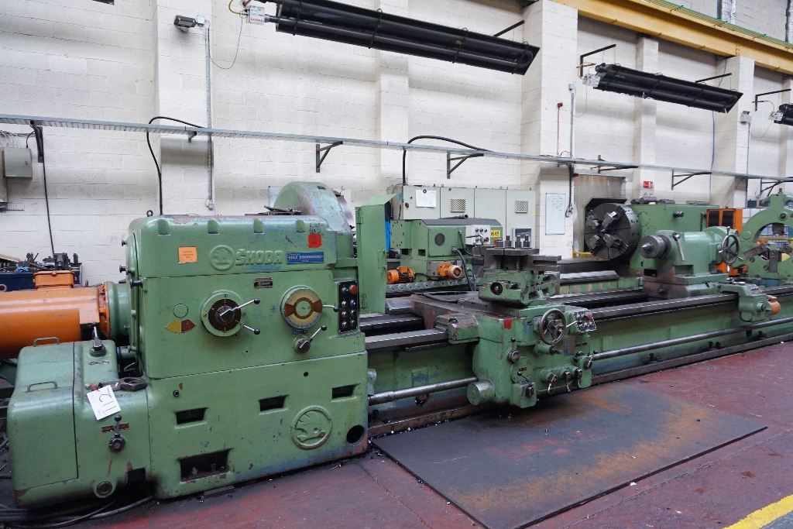
- Make : Skoda CZ
- Type : SRM 100-5000
- Age : 1976
- Mach No. s/n : Ob21111

- Swing over bed : 1.000
- Swing over support : 760
- Center distance : 5.000
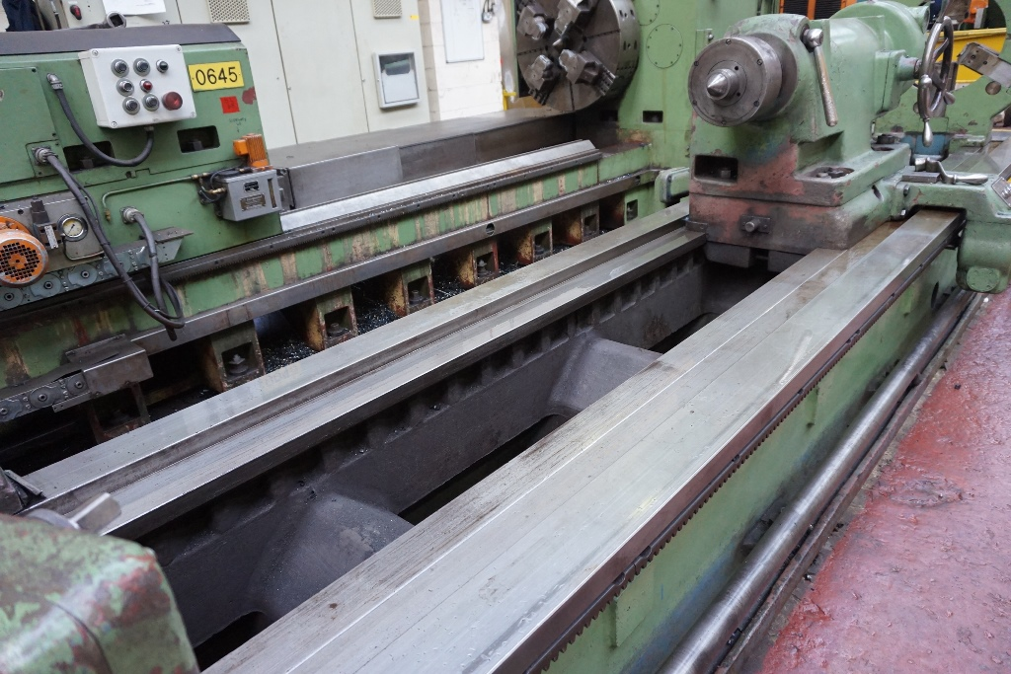
- Width off bed : 950
- Spindle hole : 120

- Work load between center : 10.000
- Load with 1 steady rest : 14.000

- Speeds : 1,8 till 400 Rpm.
- Feeds : 0,125 till 48 Rpm.
- Rapid : 3.600 mm/min.
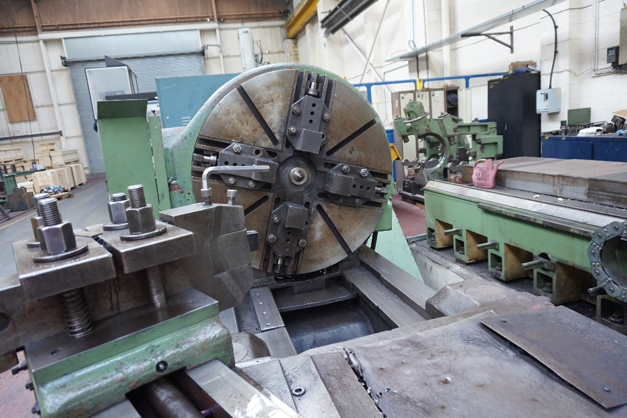

- Dimensions
- Length : 8.600
- Width : 2.100
- Height : 2.200
- Weight : 15.200 Kg

- Incl. 4 chuck Ø 1.000
- Incl. Fixed steady rest
- Power 400 V / 40 KW

Please Note: The above information has been obtained to the best of our ability and belief from, and from the manufacturers where possible. It is given in good faith, but its accuracy can not be guaranteed. Accordingly, it will not form a representation or constitute contractual terms. We advise you to check any vital details!

